Computer Programming Using Kivy 1.7.2 - GUI 9 - GUI Debugging Challenge
GOAL: Fix the bugs in the program.
Fix the bugs in my program called gui9greatcalcwithbugs.py in StudentSharedFiles, ComputerProgramming, Examples:
- Open Ninja
- File, Open, Computer, StudentSharedFiles, ComputerProgramming, Examples, gui9greatcalcwithbugs.py
- File, Save As, Computer, your home drive (H:), then change the name to gui9greatcalc.py
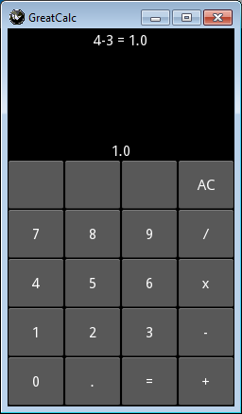
How a calculator works
A calculator always has the ability to do operations on at least 2 operands.
For example, if you use a calculator to type 12 / 3 = AC
12 is the first operand (in a python list, it would be operator 0)
/ is the operator (Division)
3 is the second operand (in a python list, it would be operator 1)
= is the equals function, which gets the result and displays it.
AC is All Clear, which erases the operation and starts over.
Math terms, and review of programming terms:
- 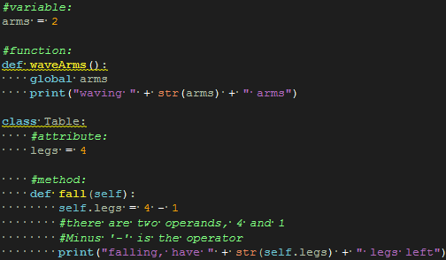 (an attribute is a variable that is part of a class, and a method is a function that is part of a class)
- Index: a number which says which item in a list to use
Review of debugging techniques:
- After you click Run File , look at the bottom of the screen in the logger window.
  - Scroll all the way down to the bottom to see the most recent part of the log before the failure.
  - Scroll up slightly in the error window until you see which line number in gui9greatcalc.py has the bug.
  - In your code, scroll to that line, and try to fix any errors (see the 3 examples below). If you see a “line is too long” warning, that will not affect the program, so ignore that and look for another problem.
  - Run File again and repeat these steps, until the program runs, and EVERY button works (try doing 12 / 3 = then to clear it click AC, then also try every other button, such as 987654321 - 1 = and make sure answer is correct)
  - Read all of the code, and fix any typing errors. For example:
    - there are variable names and keywords spelled or capitalized incorrectly (differently than other times the variable or attribute is used)
    - there is text for the user interface set to something other than what you would expect
    - there is something numbered out of sequence

BONUS: Make a working CE (Clear Entry) button (or fix any other bug that may be in the program other than the 10 that can be checked using the instructions above).

BONUS STEPS (the code added for each of these steps will be similar to any existing button):
- Define a new method named something such as doCE. Make the doCE method clear the current entry by setting self.operandList[self.operandIndex] to "".
  - Show the change by adding the line self.showEquation() as the last line of your new method.
- Set the text of any unused button to "CE": use any unused button such as self.buttons[0][2]
- Bind the button (at whatever coordinates you chose in the previous hint) to the new method you created.

